INDUR : ENVIRONMENTAL IMPACTS OF VIDEO STREAMING

## Global overview of past current and future impacts of ICT

The research of IEA(international energy agency) shows that the current carbon footprint of streaming video remains relatively modest but the future is uncertain. Video streaming is an entertainment service delivered over the internet. With the development of the time, more and more video streaming devices are used, and the resulting carbon emissions have also attracted people's attention. Due to its networked nature, it relies heavily on elements of the ICT (Information and Communications Technology) sector. And the current and historical emissions are now considered in more detail by the sub-sectors within the ICT sector’s boundary. These are: data centers, networks and end-user devices.

### Historical carbon footprint of ICT

Currently, Internet traffic is growing at a rapid rate as more and more human activities and business processes migrate to online platforms, and applications such as video streaming, social media, cloud computing, and remote working become widespread. Here data centers represent the backbone in an increasingly digitalized world. However, according to IEA’s research, the emission of data centers kept stable from 2015 to 2021, even while internet traffic has tripled since 2015 and data center “workloads” – a measure of service demand – have more than doubled. It turns out to be the result of a rapid improvement of energy efficiency.

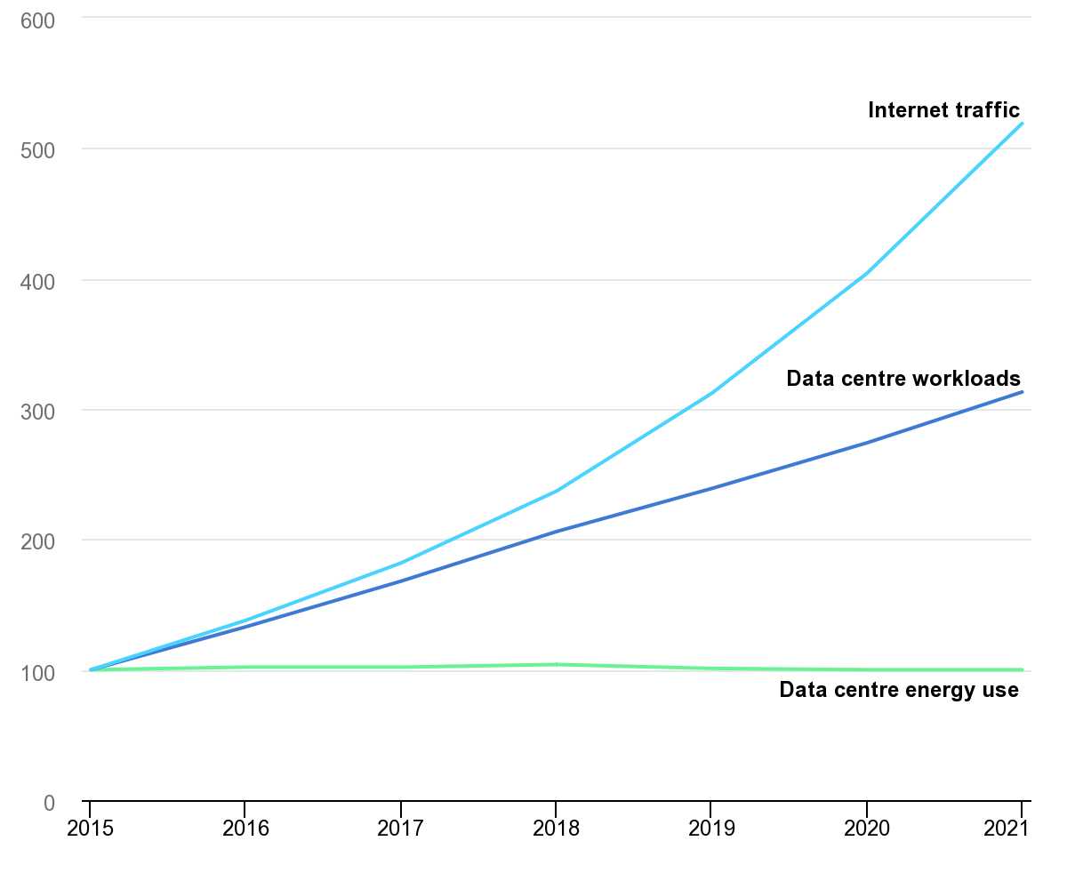

Figure: Global trends in internet traffic, data center workloads and data center energy use, 2015-2021

### Future trends in ICT carbon emissions footprint

The carbon emission is uncertain to predict. Set against the increase of efficiency is the fact that consumption of media streaming is growing quickly. Many [new video streaming](https://www.consumerreports.org/streaming-media-devices/new-streaming-video-services-to-check-out/) and cloud gaming services have also launched in recent years. Particularly noteworthy is the rapid growth in video traffic over mobile networks, which is growing at 55% per year.

Moreover, emerging digital technologies, such as machine learning, blockchain, 5G, and virtual reality, are likely to further accelerate demand for data center and network services. Researchers have started to study the potential energy and emissions impacts of these technologies.

It is becoming increasingly likely that efficiency gains of current technologies may be unable to keep pace with this growing data demand. As the figure shows, the efficiency gain has stalled theses years.

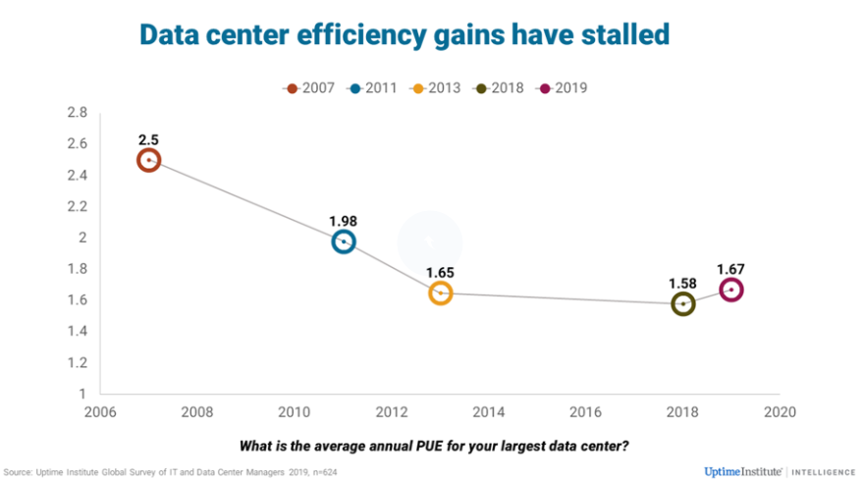

Figure: Data center efficiency gains have stalled

To reduce the risk of rising energy use and emissions, investments in new technology for the decrease of video streaming are needed, alongside continued efforts to decarbonize the electricity supply. It also shows the importance of video streaming research.

## End users devices is the biggest factor in terms of carbon emissions + data traffic

We could think that changing the quality setting of your streaming device helps you to reduce your CO2e emission. But actually, the choice of the quality settings have a relatively marginal impact on your CO2e emission in the first scope (as shown in the figures below), and as a consumer, the best way to reduce your CO2e emission is to choose wisely your watching device. The size of your device is really important, because it is the manufacturing phase which generates the most CO2e emission. But there are also other factors.

[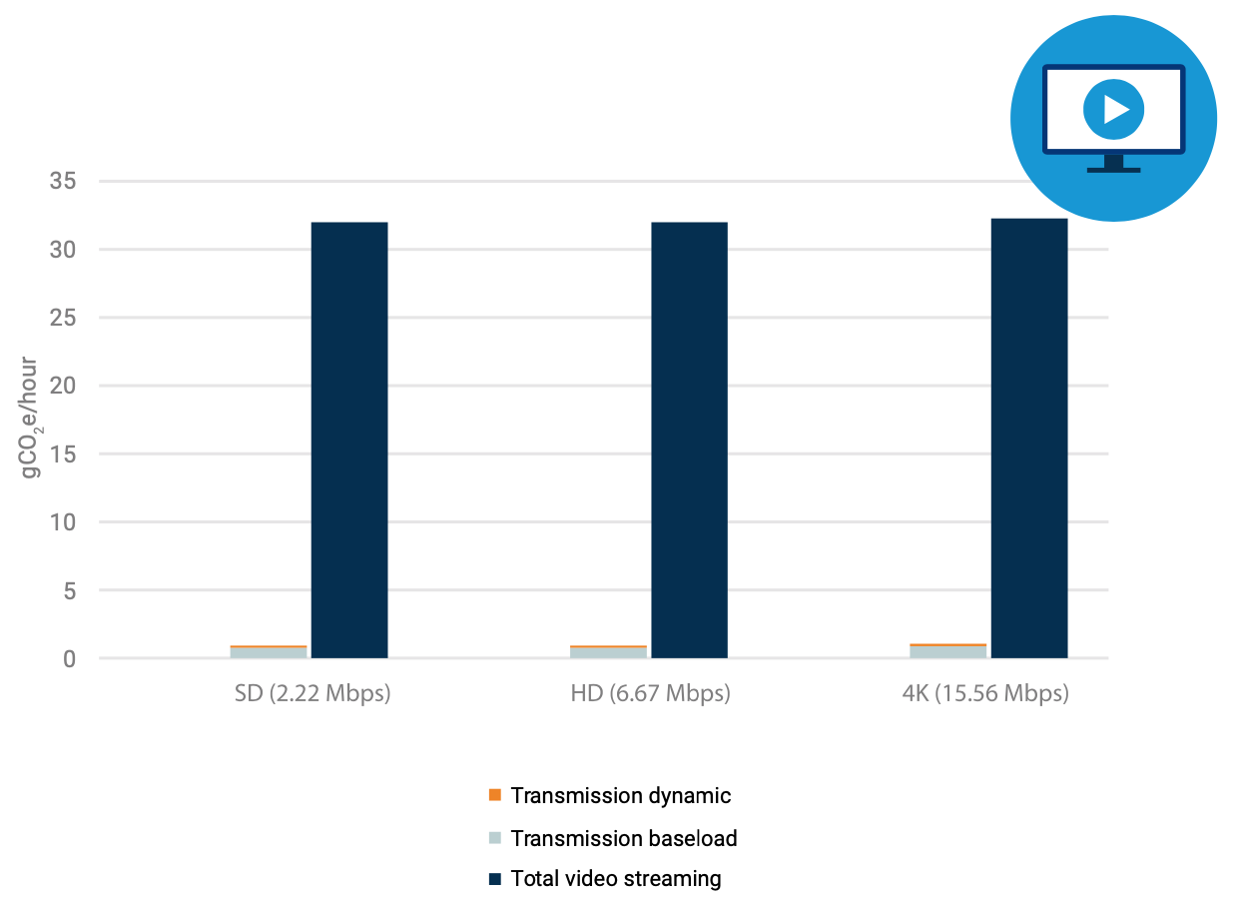](https://about.netflix.com/fr/news/the-true-climate-impact-of-streaming)

Figure ?.   CO2e emission of 1 hour streaming on a television with different quality settings

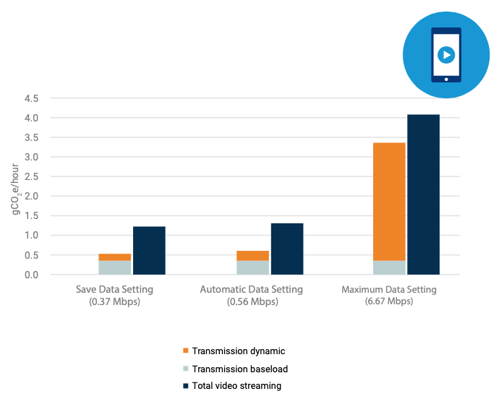

Figure ?.   CO2e emission of 1 hour streaming on a smartphone with different quality settings

As we can see on these two figures, watching streamed content on a smartphone rather than on a television can reduce your CO2e emission by a factor of 8 to 30 depending on your quality settings. We can also see that for a television, changing the quality setting has nearly no impact on the CO2e emission. It is due to the fact that the electricity consumption of the television doesn’t really change when changing quality. It is not the same for a smartphone, which has a better electricity elasticity. However, even with the maximum data setting, smartphones are 8 times better than television in terms of CO2e emission.

But is the quality setting really marginal in CO2e emission ? There is actually a hidden CO2e emission in the transmission baseload linked to quality settings. It could seem paradoxical at first, because transmission baseload is only linked to the emission required to establish the connection, and transmission dynamic are linked to the amount of bits exchanged on the network. But in order to provide a stable connection, the network has to have the capacity to handle all the traffic instantly. Therefore, increasing the quality setting will put more load on the network, requiring the providers to install more equipment, therefore more energy consumption and manufacturing CO2e emission. We can understand it through a bus line analogy. The main consumption of fuel in a bus doesn’t come from the number of passengers in a bus, but to get the bus moving first. But if there are more and more passengers on the line, which reach a saturation point, the company will have to put more buses on the line, which will drastically increase the CO2e emission. Therefore, being reasonable on the load you’re putting on the network with the choice of quality settings is also a good way for the consumer to reduce the environmental impact of streaming.

## What about other impacts ?

The Ademe study develops how video streaming impacts environments in many ways and the survey highlights the differences between streaming consumption methods and a DVD scenario (non-digital video consumption). In the figure below, one can see the indicators used to evaluate the scenarios in several domains.

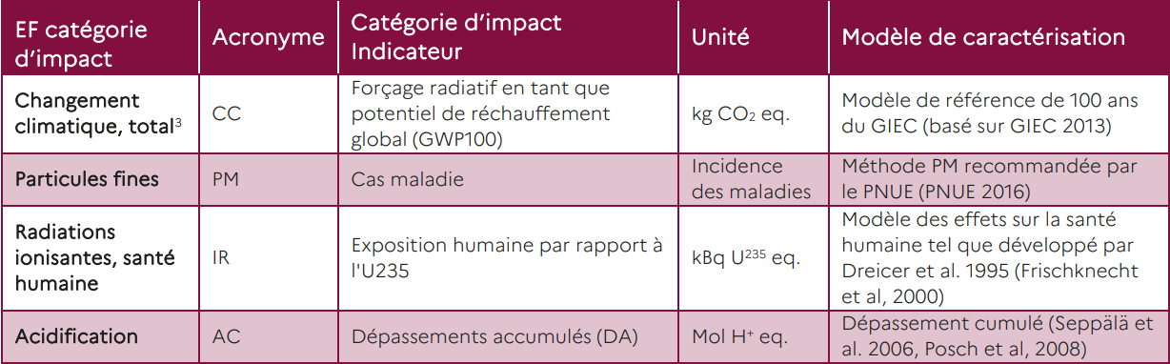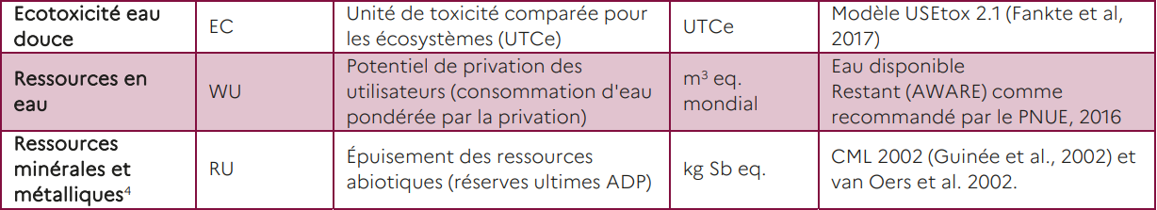

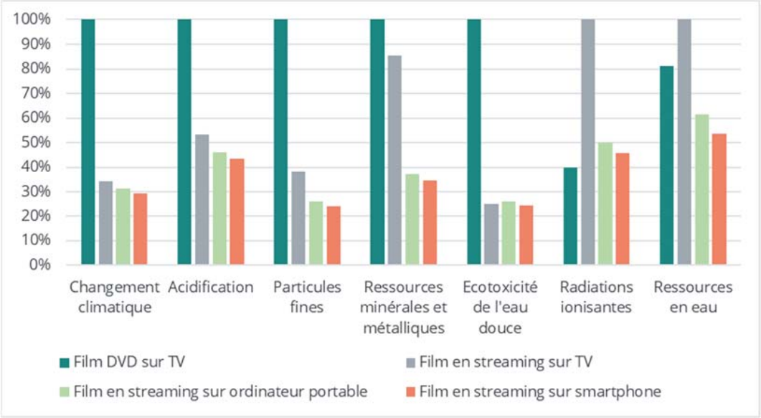

Thanks to the graphic above, one can assert that DVD represents a major impact on all indicators (but it highly depends on its usage time). DVDs are not necessary in digital scenarios, but data consumption generates non-negligible impacts (that strongly varies with the selected resolution) on climate change and other types of contamination.

Regarding the smartphone streaming scenario, there is a supplementary parameter : connection type. The impact of 1 Go transmission is greater with a wireless mobile connection than with a fixed broadband one. However, by default data consumption is lesser with a wireless mobile connection. All in all, the final impact is smaller with this connection type.

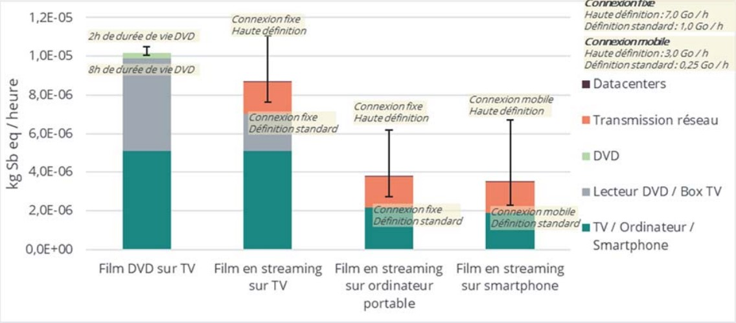

The last graphic represents a comparison of the impacts of all scenarios regarding the mineral and metallic resources run out, taking into account the results uncertainty.

This time the service “DVD on TV” has more than 97% of its impact linked to its equipment. So that is why the variation in DVD using time has a slight impact in this case compared to the climate change indicator.

For digital services, the network has a non-negligible impact. Thus, parameters such as resolution and connection type have a greater influence.

## Adrian’s conclusions on others using methods with high impacts

Proposition to conclude on the users’ behaviors and the rebound effects

The main conclusion here is the prominent impact of the device in the carbon emissions and other environmental impacts of video streaming and not the video resolution as we could have expected.

In one of the studies we’ve chosen to cite, we see a strong link between mobile plan size, subscription plan to paid streaming platforms and the weekly hours spent streaming **[2]**. Logically, these 2 factors are highly related to age and income which means this question, like many others linked to environmental impacts of our lives, is deeply linked **(???)** to our socio-economical society model. But as streaming is becoming more and more widespread among all slices of the population and the role of online data transmissions is growing day after day, this question is less and less limited to young and wealthy individuals.

This underlines the need for public information on these topics as many **(some ?)** people might think they are doing their part in reducing their streaming related carbon footprint by reducing their video quality setting. But good information isn’t just facts and figures, it needs to be put in context and quantified relatively to other metrics.

We can cite 3 different types of environmental knowledge **[1]** :

* system knowledge refers to ecosystems and ecological problems caused by human behavior i.e. the big picture
* action knowledge points up the concrete behavioral options that people can add to their daily routine
* effectiveness knowledge based on the ecological impact of each behavioral option relatively to the main figures of the issue

Well documented and widespread **(???)** knowledge on this issue is mandatory to help reduce our global impact and to limit the rebound effect caused by the democratization of the video streaming offers. As you all know, the rebound effect, or Jevons Paradox **(initially for coal)** describes the situation **(???)** when an improvement allows a technology or an habit to become more widespread in the population and thus increasing its global impact. The reduction of data transmission costs lowering the prices of subscription plans of many platforms in recent years (even if they are increasing lately) has allowed them to become overwhelmingly popular and to take more and more time in our daily life, leading to an explosion of the video streaming flows **(???)**. And this is not only concerning the young, it’s spreading among all age groups, making it a non neglectable issue.

We need to improve our consumption habits in the light of the figures and studies available with tangible actions. But these changes can only be made in cooperation with streaming platforms (eg allowing music video to ba audio only on Youtube could reduce the platform GHG emission by 6% **[3]**), whether it comes from their own initiative or an obligation on our governments' behalf.

## Sources

1 - *Reducing the Individual Carbon Impact of Video Streaming: A Seven‑Week Intervention Using Information, Goal Setting, and Feedback*  - B. T. Seger · J. Burkhardt · F. Straub · S. Scherz · G. Nieding

2 - *All you can stream: Investigating the role of user behavior for greenhouse gas intensity of video streaming* - Paul Suski, Johanna Pohl, Vivian Frick

3 - *Evaluating Sustainable Interaction Design of Digital Services: The Case of YouTube* - C. Preist, D. Schien, and P. Shabajee